Security Analysis of dvd_rental Database (With Evidence)

1. Users and Roles (Evidence Included)
SQL Query:
SELECT * FROM pg_roles;
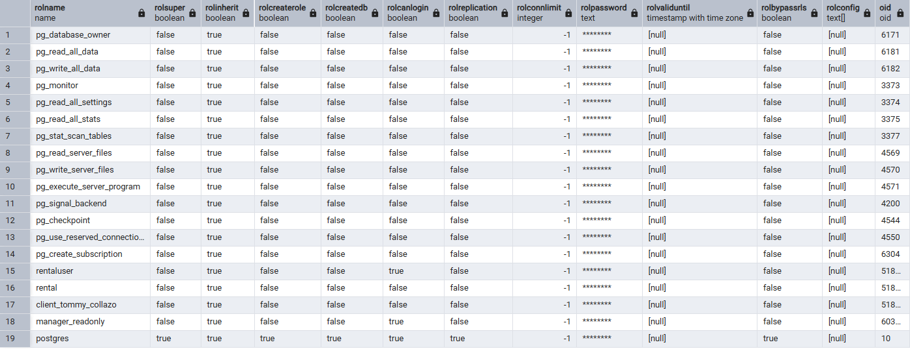
Output (excerpt):
pg_database_owner
pg_read_all_data
pg_write_all_data
...
rentaluser
rental
client_tommy_collazo
manager_readonly
postgres (superuser)
Analysis:
Multiple roles exist. postgres is a superuser with full privileges. Custom roles like rentaluser and manager_readonly show role-based access control.

2. Table-Level Privileges (Evidence Included)
SQL Query:
SELECT grantee, privilege_type, table_name
FROM information_schema.role_table_grants
WHERE table_schema = 'public';

2. Table-Level Privileges (Evidence Included)
SQL Query:
SELECT grantee, privilege_type, table_name
FROM information_schema.role_table_grants
WHERE table_schema = 'public';
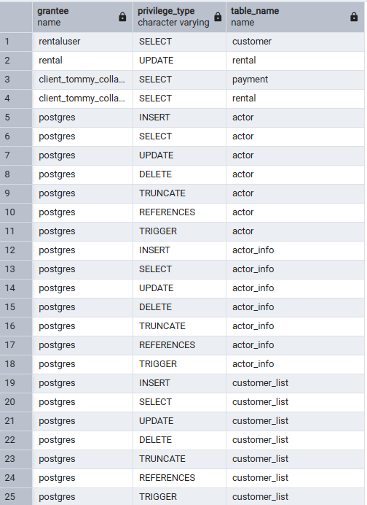
rentaluser → SELECT on customer
rental → UPDATE on rental
client_tommy_collazo → SELECT on payment, rental
postgres → ALL privileges on all tables
Analysis:
Privileges are distributed across roles, limiting access for some users. However, postgres
has full access everywhere.

3. Table Ownership (Evidence Included)
SQL Query:
SELECT tablename, tableowner FROM pg_tables WHERE schemaname='public';
Output:
All tables (actor, store, address, etc.) → owned by postgres
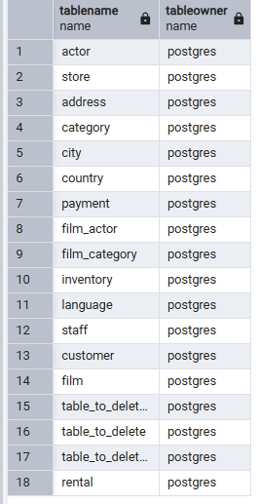
Analysis:
Centralized ownership increases risk if postgres is compromised.

4. Password Security (Evidence Included)
SQL Query:
SELECT rolname, rolpassword FROM pg_authid;
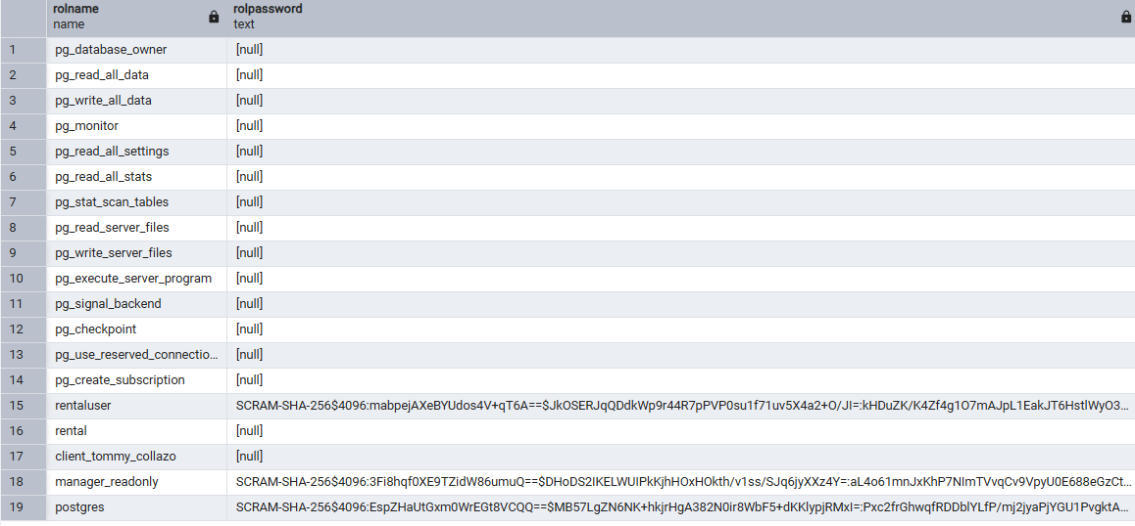
Output (excerpt):
rentaluser → SCRAM-SHA-256 hashed password
manager_readonly → SCRAM-SHA-256 hashed password
postgres → SCRAM-SHA-256 hashed password
Analysis:
Passwords are securely stored using SCRAM-SHA-256.

5. Row-Level Security (Evidence Included)
SQL Query:
SELECT relname, relrowsecurity FROM pg_class WHERE relkind='r';
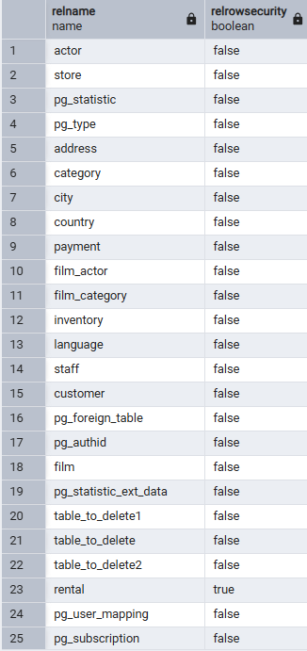
Output:
rental → true
other tables → false
Analysis:
Only rental table has Row-Level Security enabled. Other tables lack fine-grained access control.

6. Constraints (Evidence Included)
SQL Query:
SELECT conname, contype FROM pg_constraint;
Output (excerpt):
Primary keys (p): actor_pkey, customer_pkey, rental_pkey
Foreign keys (f): rental_customer_id_fkey, payment_customer_id_fkey
Check constraints (c): year_check
Analysis:
Constraints ensure data integrity and consistency.

7. Security Evaluation
Strengths:
- Role-based access control implemented
- Encrypted passwords (SCRAM-SHA-256)
- Data integrity via constraints
Weaknesses:
- Most tables lack Row-Level Security
- All tables owned by postgres
- Powerful built-in roles (pg_read_all_data)

8. Vulnerability Identified
Risk:
If postgres or pg_read_all_data role is compromised, attacker gains full database access.
Impact:
- Data leakage
- Unauthorized modification or deletion

9. Recommendations
- Enable RLS on sensitive tables (customer, payment)
- Avoid using postgres for daily work
- Create least-privilege roles
- Enable logging and auditing
- Restrict powerful predefined roles

